**Figures**



**Figure 1: Data structure.** We are using a data set composed of 155 samples. For 152 of them we have whole-transcriptome RNA-Seq reads and for 105 of them we have mass-spec proteomics reads, 103 of 155 samples have corresponding mRNA and protein reads. Data covers four different carbon sources: glucose, glycerol, gluconate, and lactate; and variation for two different ions: high sodium and both low and high magnesium. Collected samples span a two-week interval, which can be divided into 3 growth phases exponential stationary and late stationary.

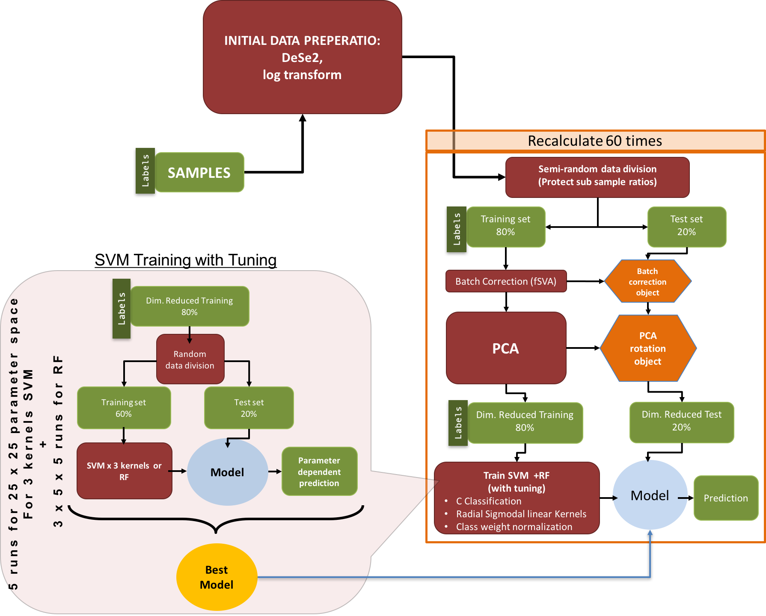

**Figure 2: Machine learning pipeline.** The machine learning pipeline can be separated into three parts. Initial process test loop and tune loop. After initial preparation data is separated into 2 parts as training and test, after applying fSVA and PCA to training data we obtain we apply a C-Classification SVM with radial sigmoidal or linear kernel or Random Forest with given class weights which are used to get rid of the penalty on categories with few samples. After obtaining the model from SVM we apply the model on test data which was batch corrected and rotated with batch correction object and PCA rotation object.

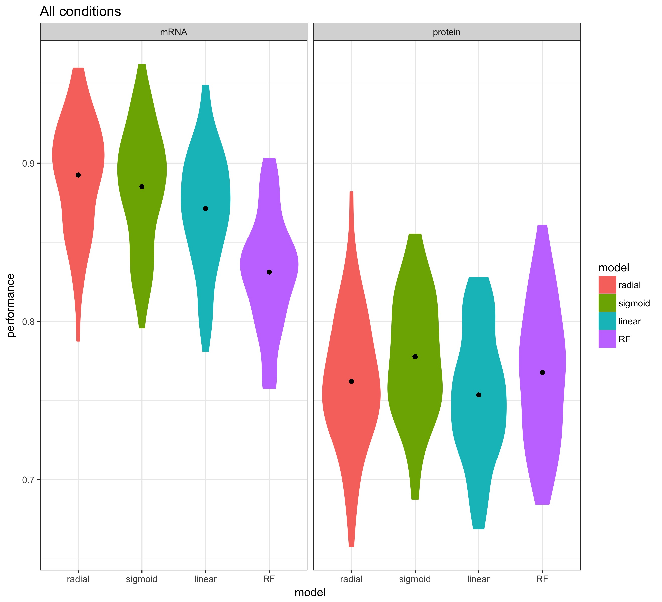

**Figure 3: Complex predictions based on mRNA data.** SVM with radial kernel is the best performing model, with best performance 49 out of 60 runs. Prediction results of 60 different best fits of winner model (SVM with radial kernel) is used to predict test data sets. Rows represent conditions investigated and the columns represent the predictions. The numbers in the cells represent what percent of true positives predicted as the relevant column. Sum of trace is 1003.6.

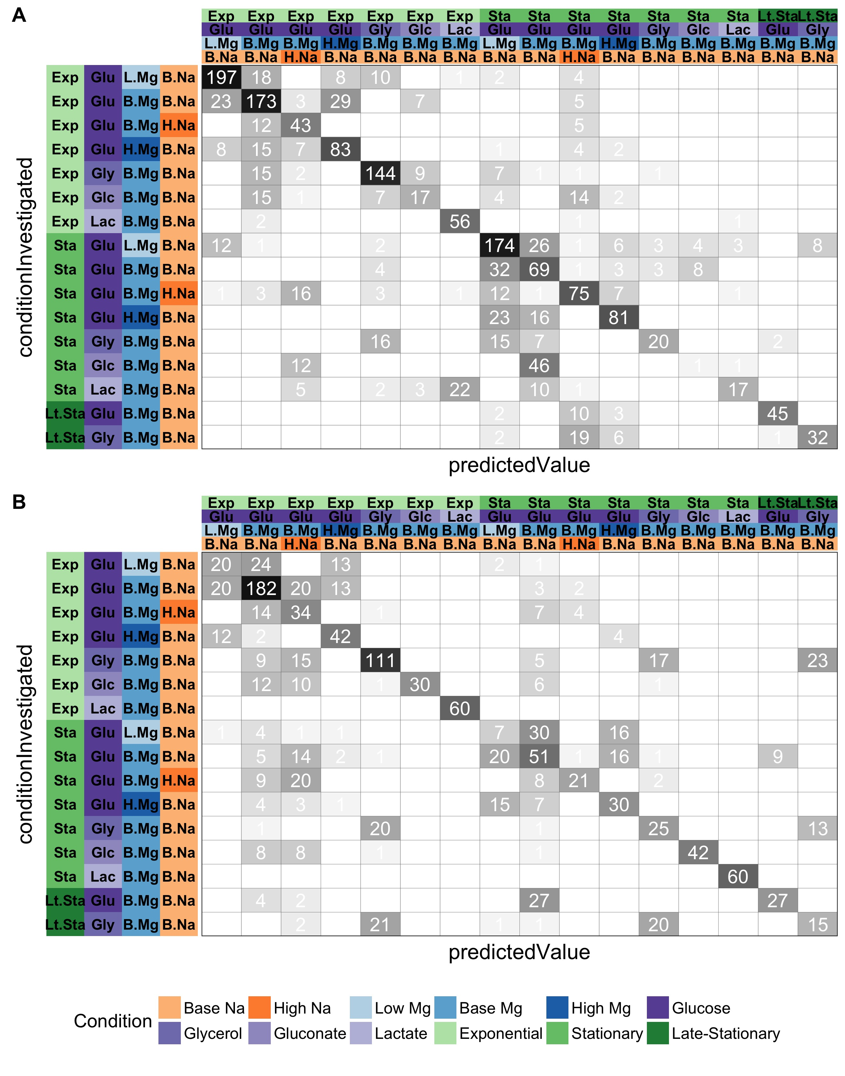

F**igure 4. Complex predictions based on protein data.** SVM with sigmoidal kernel is the best performing model with best performance 42 out of 60 runs. Prediction results of 60 different best fits of winner model (SVM with sigmoidal kernel) is used to predict test data sets. Rows represent conditions investigated and the columns represent the predictions. The numbers in the cells represent what percent of true positives predicted as the relevant column. Sum of trace is 870.4.

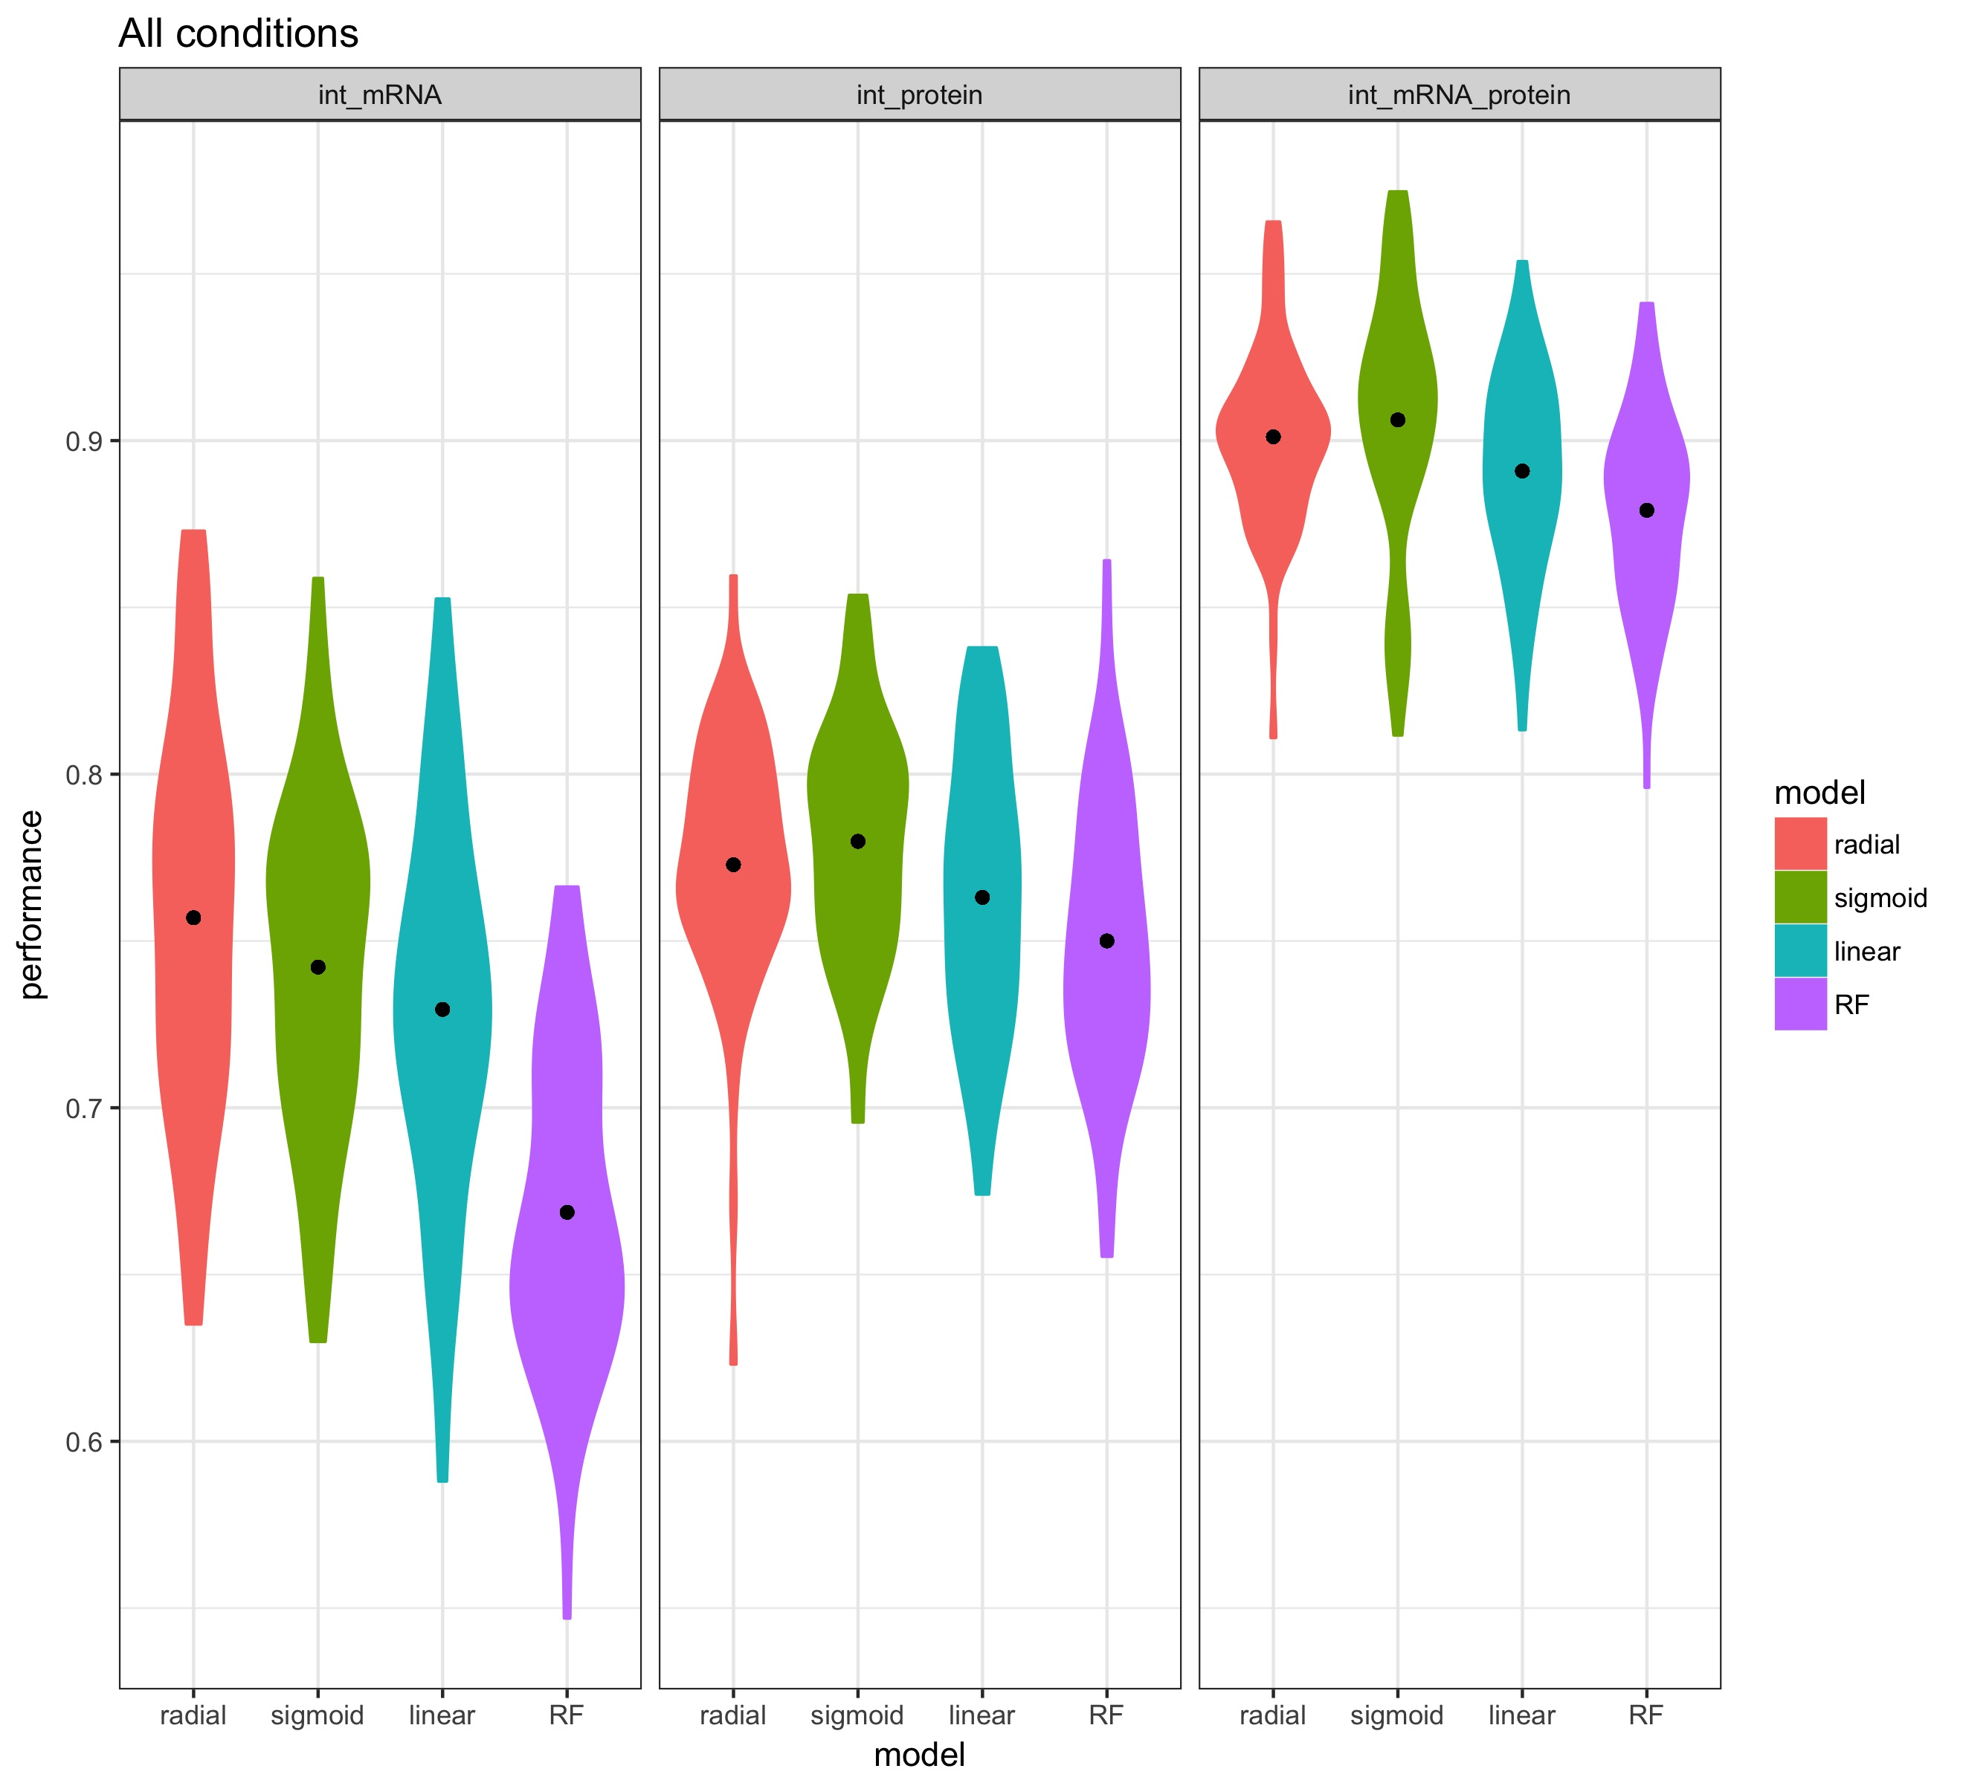

Multi conditional F1 Score

**Figure 6. Performance increase after combining mRNA and protein data, compared with performance of mRNA and protein data alone.** The sub data sets that match between proteins and mRNA’s are used to compare the performance of machine learning models on; only mRNA, only protein and mRNA & protein data. The increase in the performance indicates additional information associated with post translational regulation. Performance increase is independent of the used model.

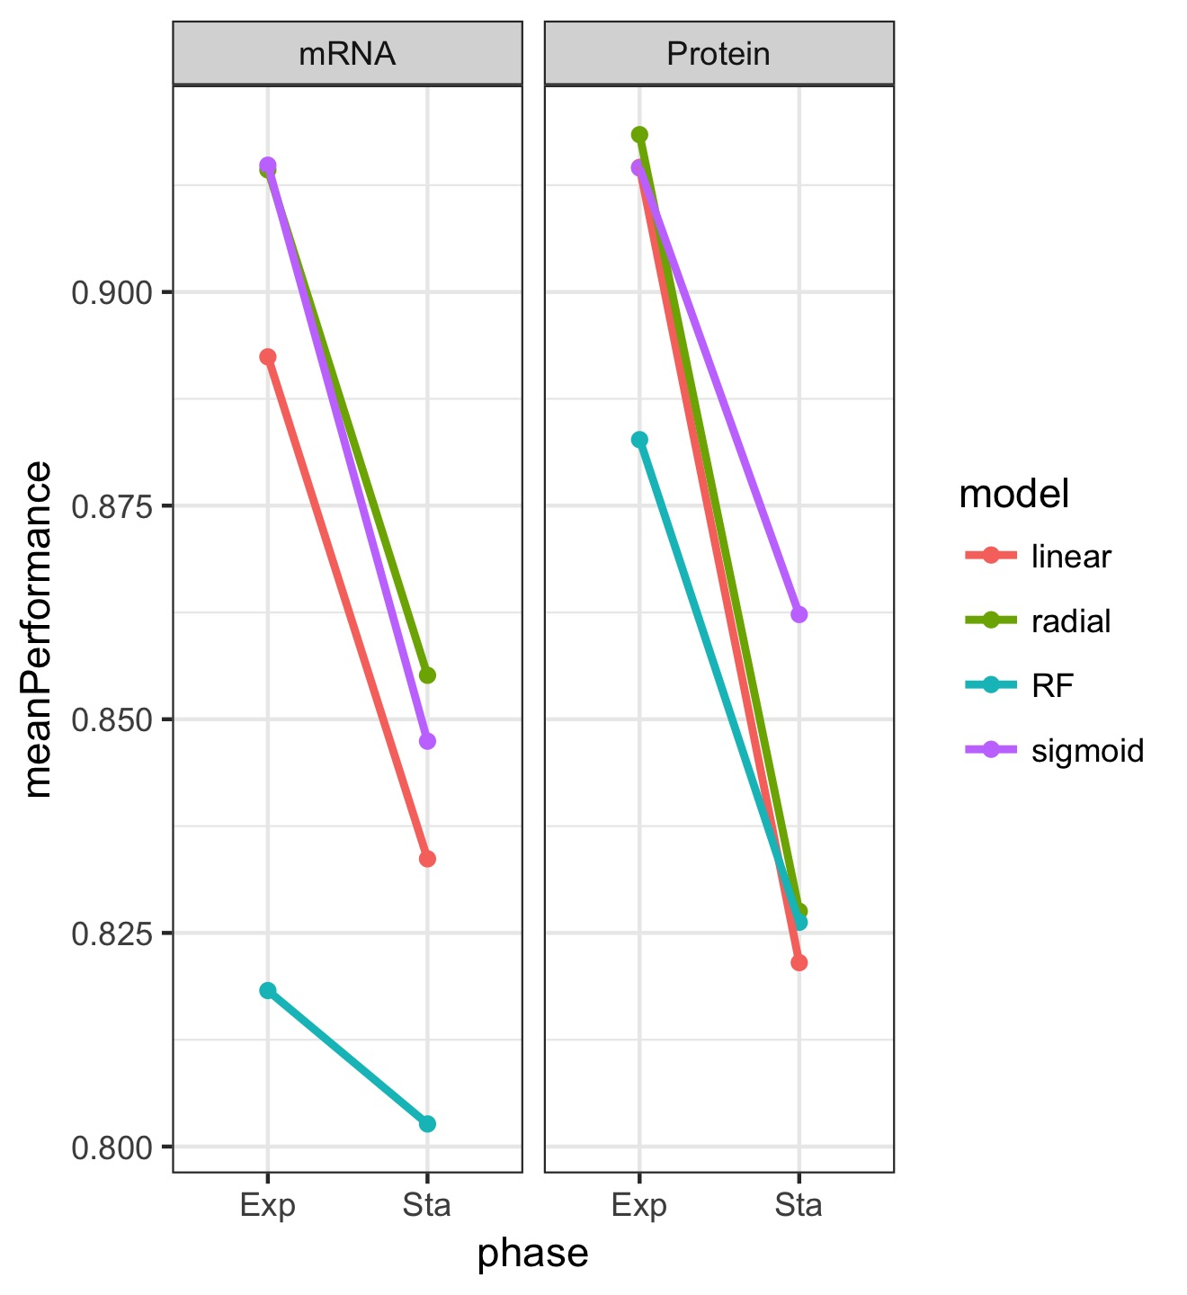

**Figure 7. Overall prediction trends in time.** Summary results for 3 different conditions carbon source, Mg levels, Na levels for 2 different growth phases exponential and stationary with multiple models. The success variable in y axis is F1 score. The trends between exponential and stationary phase represents the decrease in predictability; and this situation is consistent with different models. The results for Na+1 are not trustable because of small sample size.